**Meeting Minutes**

**Date:** March 3, 2014

**Start Time:** 6:00pm

**End Time:** 8:00pm

**Members Present:** Drew Aaron, Michael Beaver, Clay Boren,

Chad Farley, Andrew Hamilton, and Travis Hunt

**Members Absent:** N/A

**Topics** **Discussed**

* Architectural Design
* Division of Labor

**Decisions and Actions Taken**

The team discussed the architectural designs of the ASSIST/UNA frontend and backend. The frontend has essentially been divided into groups of classes that correspond to the GUI interfaces and menu options. The details of the interfaces and interactions have not been determined at this time. The basic flow of data is from the periphery classes through the Main Screen class to the backend.

The backend is essentially divided into the Assembler and Simulator. The Assembler will take input directly from the frontend; the exact interface will be determined later. The Assembler will carry out its two passes and partially generate the .PRT file. Any errors from the second pass will be sent to the Error Detection module. The object code from the Assembler will be sent to the Simulator, if necessary. The Simulator will then simulate execution on an IBM/360 mainframe. Any runtime errors will be sent to the Error Detection module. Output from the Simulator and the Error Detection modules will be sent to the frontend.

At this time, the team believes that the Simulator portion of the backend will be the most challenging and time-consuming to implement. Hence, a concerted effort may be made to create the Simulator and the Assembler, perhaps concurrently, in a timely manner. The team will better demarcate the division of labor at the next team meeting.

The next team meeting will be at 3:30pm on March 4, 2014 in the Keller Lab.

**Supplementary Information**

**Frontend Architectural Design**

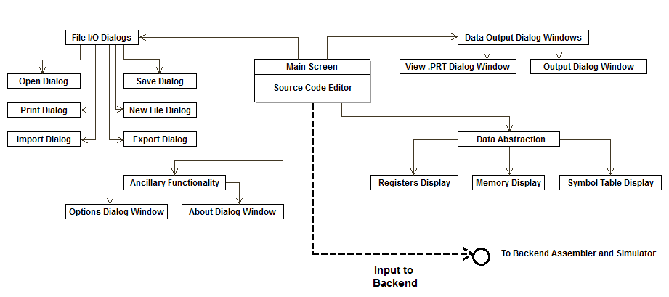

**Backend Architectural Design**

